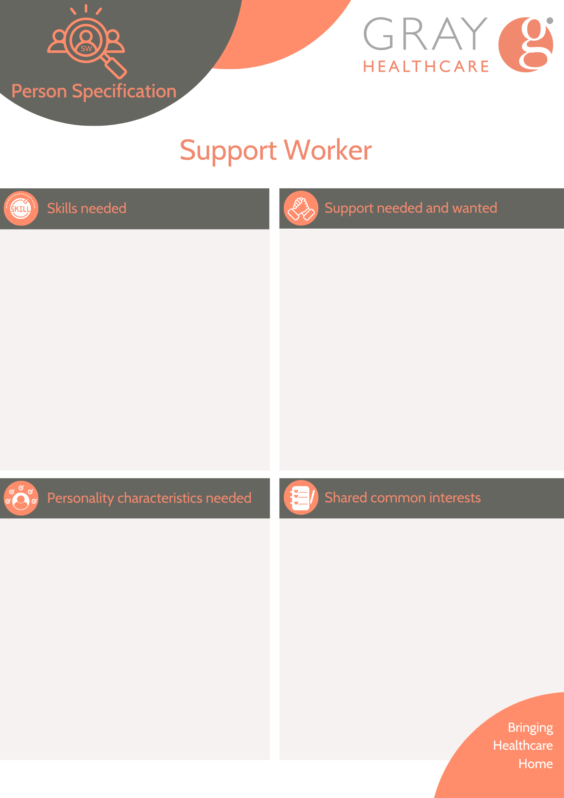
Honesty
Open minded
Kind
Empathic
Flexible
Cheerful
Friendly
Punctual
Technological (savvy)

Pets (cats)
Social media
Writing (poems)

Respect my space.
Prompting to complete tasks
Encouraging healthy food choices
Observant in declines / health
Encouraging more activities
Active (person)
Enjoys cooking.

Good listener
Clear communication
Ability to recognise triggers and follow plans accordingly
Stay calm in challenging situations.
Motivated
High level of patience and emotional resilience.

